**We would like to thank both reviewers for taking the time to offer many constructive and helpful suggestions that have assisted in improving the quality of the manuscript. We have revised our manuscript based on the comments and corresponding responses. We believe that the resulting manuscript is consequently much improved over the initial submission. Responses to individual comments can be found below.**

**Reviewer #1 Evaluations:**

This study uses the Community Earth System Model (VR-CESM) with the variability of variable-resolution to understand the impact of irrigation on the regional climate of California. The advantage of the variable-resolution is to use smaller grids (higher resolutions) around California to setup the irrigation processes in a land surface model, which seems to be a reasonable approach. In general, this study found similar results with many previous studies of using either numerical model simulations or observations on the local impacts of irrigation, such as cooling and moistening effects. However, they also found some differences from the previous studies, and the authors can make more efforts to tell the readers why? instead of saying "this result suggests the irrigation cannot explain cooling and enhanced precipitation as argued by previous studies". More explanations and evidences will be needed in the revised manuscript. Please also see the detailed comments listed below.

While this study points an interesting irrigation's local effects and important applications on California's extreme climate, the analysis in this study needs to be improved in order to support what the authors want to convey. Overall, the findings presented in this paper may be of interest to the community; however, a revision is definitely needed in order to support what the authors want to deliver. There are several aspects that need to be addressed before the paper is accepted. Please see below for detailed comments.

1.While this study uses a unique model, however, what is the overall performance of VR-CESM? The global pattern of precipitation/circulation compared to reanalysis data may be useful. The spatial map of the overall atmosphere circulation looks like when compared to the reanalysis data? Does it look reasonable when using VR-CESM? Also, how does it change when applying the irrigation?

**Thanks for bringing up these observations. The overall performance of CESM in modeling California’s climate has been addressed in detail in Huang et al. (2016), which demonstrates VR-CESM has competitive biases when compared with a regional climate model forced by reanalysis data, as evaluated against high-quality observations and reanalysis datasets. Rhoades et al. (2015) has also assessed the promising use of VR-CESM for modeling Sierra Nevada mountain snowpack in the western United States. Variable resolution has also been employed by Zarzycki et al. (2014) to show that a high-resolution refinement patch in the Atlantic basin for simulating tropical cyclones represented significant improvements over the unrefined simulation.**

**Zarzycki et al. (2015) have compared the large-scale climatology of VR-CESM 0.25 $°$ and uniform CESM at ~1 $°$, evaluated against reanalysis (MERRA, NCEP), and found that adding a refined region over the globe did not significantly affect the global circulation. In our study, as in Zarzycki et al. (2015), general circulation patterns (e.g., wind, pressure and precipitation) do not exhibit apparent artifacts in the variable-resolution transition region, and the design of the SE dynamical core ensures that dry air and tracer mass are conserved globally [Dennis et al. 2011; Taylor and Fournier 2010; Taylor 2011].**

**Global properties of irrigation are beyond the scope of this study, but have been addressed in other studies [Lobell et al. 2006; Sacks et al. 2009]. In particular, Sacks et al. (2009) has investigated how irrigation affects the global climate by focusing on near-surface temperatures, using the Community Atmosphere Model (CAM) 3.0 coupled to the Community Land Model (CLM) 3.5 at grid resolution of 2.8 $°$. We have also explored the possible mechanisms by which irrigation may bring about large-scale change, including changes to the latent heat flux, near-surface specific humidity, precipitation and cloud cover. Since the quantitative impacts are quite similar to what has been shown in Sacks et al. (2009), we did not add this assessment to the manuscript.**

**To further understand the quality of the global circulation simulated by CESM, the geopotential height at 500 hPa (Z500) for all simulations and NCEP Climate Forecast System Reanalysis (CFSR) reanalysis are displayed in Figure 1: VR-CESM exhibits a similar pattern to CFSR, though it tends to exhibit a warm bias in the northern hemisphere (corresponding to a positive bias in Z500) and cold bias in the southern hemisphere (with associated negative bias in Z500); a similar magnitude in this positive bias for Z500 has also been found in the uniform CESM at 1 degree averaged over JJA from year 1980 to 2004, compared against several reananlysis dataset such as NCEP, ERA-interim and others. This data can be found at (**[**http://webext.cgd.ucar.edu/FAMIP/f.e12.FAMIPC5.ne30_ne30.amip_L30.001/atm/f.e12.FAMIPC5.ne30_ne30.amip_L30.001-obs/set5_6/set5_6.htm**](http://webext.cgd.ucar.edu/FAMIP/f.e12.FAMIPC5.ne30_ne30.amip_L30.001/atm/f.e12.FAMIPC5.ne30_ne30.amip_L30.001-obs/set5_6/set5_6.htm)**).**

**Nonetheless, even with this the global atmosphere circulation looks reasonable when using VR-CESM. We can also see that applying the irrigation did not impact the general circulation pattern, as all simulations show similar geopotential patterns with only a few regions exhibiting significant difference (defined as locations with p-value < 0.05). Since no clear pattern was present in regions with statistically significant differences (among NRG, IRG(0.5) and IRG), and there is no clear physical mechanism to connect these regions with irrigated regions, we attribute these differences to insufficient ensemble size. This figure has been added to the supplementary material for the paper.**

**On lines 129-131 of the revised manuscript, we have added: “In our study, as in Zarzycki et al. [2015], general circulation patterns (e.g., wind, pressure and precipitation) do not exhibit apparent artifacts in the variable-resolution transition region.”**

**On lines 391-400, we have added: “We have also explored the possible mechanisms by which irrigation may bring about global change, including latent heat flux, near-surface specific humidity, precipitation and global cloud cover. The quantitative impacts are quite similar to what has been obtained in Sacks et al. [2009], and so are not repeated here. In order to determine if irrigation changes the overall atmosphere circulation, the 500 hPa geopotential height field was examined (see Figure 2 in supplement). We observed that the large-scale pattern was similar in all cases, although statistically significant differences did sporadically arise. Since no clear pattern was present among regions with statistically significant differences, and there is no clear physical mechanism to connect these regions with irrigated areas, we attribute these differences to insufficient ensemble size.”**

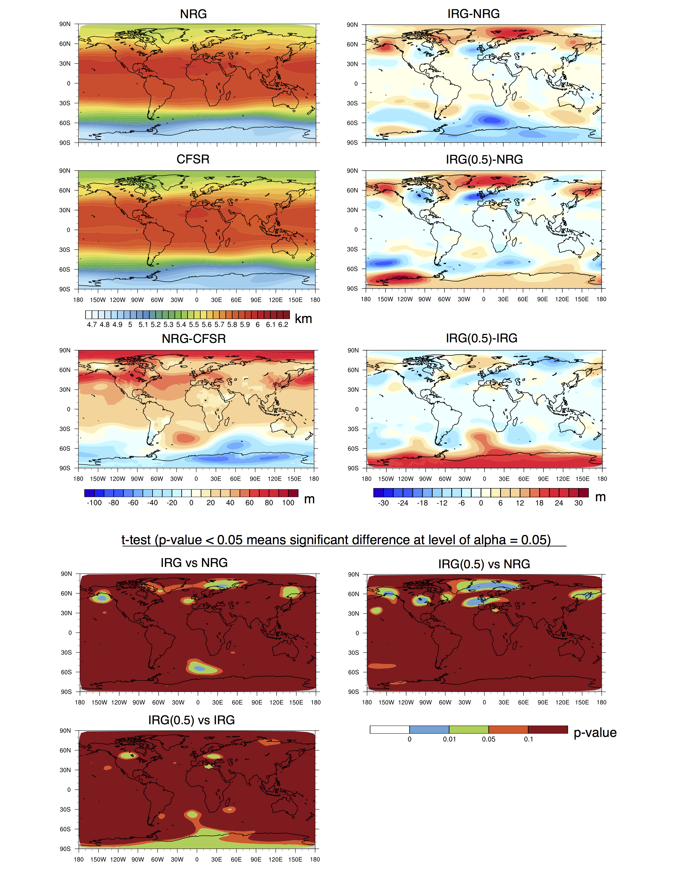

**Figure 1. Geopotential height at 500 hPa for simulations (averaged over JJA from 1980-2005).**

References:

Huang, X., A. M. Rhoades, P. A. Ullrich, and C. M. Zarzycki (2016), An evaluation of the variable-resolution CESM for modeling California’s climate, Journal of Advances in Modeling Earth Systems, (2016).

Rhoades, A. M., X. Huang, P. A. Ullrich, and C. M. Zarzycki (2015), Characterizing Sierra Nevada snowpack using variable-resolution CESM, Journal of Applied Meteorology and Climatology, (2015).

Zarzycki, C. M., C. Jablonowski, and M. A. Taylor (2014b), Using Variable-Resolution Meshes to Model Tropical Cyclones in the Community Atmosphere Model, Monthly Weather Review, 142(3), 1221–1239.

Zarzycki, C. M., C. Jablonowski, D. R. Thatcher, and M. A. Taylor (2015), Effects of localized grid refinement on the general circulation and climatology in the Community Atmosphere Model, Journal of Climate, 28(7), 2777–2803.

Dennis, J., J. Edwards, K. J. Evans, O. Guba, P. H. Lauritzen, A. A. Mirin, A. St-Cyr, M. A. Taylor, and P. H. Worley (2011), CAM-SE: A scalable spectral element dynamical core for the Community Atmosphere Model, International Journal of High Performance Computing Applications, p. 1094342011428142.

Taylor, M. A. (2011), Conservation of mass and energy for the moist atmospheric primi- tive equations on unstructured grids, in Numerical Techniques for Global Atmospheric Models, pp. 357–380, Springer.

Taylor, M. A., and A. Fournier (2010), A compatible and conservative spectral element method on unstructured grids, Journal of Computational Physics, 229(17), 5879–5895.

Lobell, D., G. Bala, and P. Duffy (2006), Biogeophysical impacts of cropland management changes on climate, Geophysical Research Letters, 33 (6).

Sacks, W. J., B. I. Cook, N. Buenning, S. Levis, and J. H. Helkowski (2009), Effects of global irrigation on the near-surface climate, Climate Dynamics, 33 (2-3), 159–175.

2. Line 335~339: The authors indicated that the night time cooling as argued by Bonfils and Lobell [2007] can not be shown in the VR-CESM. The authors need to provide more evidences on why the model can't see such changes?

**Sorry for the confusion. We should clarify our statement; what we intended to point out here is that, as argued by Bonfils and Lobell (2007), our result further supports the conclusion that irrigation does not completely explain the large nighttime warming observed in California. More details can be found in Bonfils and Lobell (2007).**

**The dependence of the sign of the change in Tmin associated with irrigation practices on the irrigation parameterization and the assessed climate model has also been found in Kueppers et al. (2008). In Kueppers et al. (2008), Kanamaru and Kanamitsu (2008), they used four models and found warming of Tmin in the RSM (Regional Spectral Model), but cooling in RegCM3 (the third generation of the Regional Climate Model). They further argued that the differences in the response of Tmin to irrigation might be due to the discrepancy in soil properties and natural vegetation types with their effects on soil heat capacity and conductivity, and on the nighttime soil-air temperature gradient.**

**According to the technical notes of CLM 4.0, the thermal properties (e.g, heat capacity and thermal conductivity) of the soil are assumed to be a weighted combination of the mineral and organic properties of the soil at each layer (Lawrence and Slater 2008). The soil texture and organic matter content defined by the surface data for each land grid cell determine the soil thermal and hydrologic properties.**

**On lines 364-371, we replaced “**This result suggests that irrigation cannot really explain the large nighttime warming observed in California, as argued by Bonfils and Lobell [2007].**” with “As argued by Bonfils and Lobell [2007], our result further supports the conclusion that irrigation does not completely explain the large nighttime warming observed in California. As discussed in Kueppers et al. [2008] and Kanamaru and Kanamitsu [2008], the sign of the change in Tmin associated with irrigation depends on the particular parameterization and the assessed climate model. These differences are further associated with differences in soil properties, including soil heat capacity and conductivity, and on nighttime soil-air temperature gradient.”**

References:

Bonfils, C., and D. Lobell (2007), Empirical evidence for a recent slowdown in irrigation- induced cooling, Proceedings of the National Academy of Sciences, 104(34), 13,582– 13,587.

Kueppers, L. M., M. A. Snyder, L. C. Sloan, D. Cayan, J. Jin, H. Kanamaru, M. Kana- mitsu, N. L. Miller, M. Tyree, H. Du, et al. (2008), Seasonal temperature responses to land-use change in the western United States, Global and Planetary Change, 60(3), 250–264.

Kanamaru, H., and M. Kanamitsu (2008), Model diagnosis of nighttime minimum tem- perature warming during summer due to irrigation in the California Central Valley, Journal of Hydrometeorology, 9(5), 1061–1072.

Lawrence, D.M., and Slater, A.G. 2008. Incorporating organic soil into a global climate model. Clim. Dyn. 30. DOI:10.1007/s00382-007-0278-1.

3. Line 340~347: the authors indicated that the strengthening of the circulation can't be seen in VR-CESM, and also indicated "Notably, the moisture flux did not differ between NRG and IRG over the irrigated area and its surroundings." What kind of moisture flux? Why the result is different from Lo and Famiglietti [2013]? Can the author discuss on why and how?

**Yes, we should explain those with more details. Lo and Famiglietti (2013) stated that increases in evapotranspiration and water vapor export caused by irrigation over Central Valley significantly impacts the atmospheric circulation in the southwestern United States, including strengthening the regional hydrological cycle, using coupled CAM 3.5 and CLM 3.5. However, the resolution of their simulations is 1.4° × 1.4°, relatively coarse to account for the variability over CV, and includes only one irrigation run which directly increased the soil moisture to include all the irrigated water (namely, it did not account for runoff).**

**In figure 2 (below), we have plotted the related variables to further identify how our results differ from Lo and Famiglietti (2013). We acknowledge that our results cannot be compared “apples to apples” to Lo and Famiglietti (2013), however the general conclusions should still hold. This figure has been added to the supplementary material for the paper. From the figure, we can see there are no significant changes at 90% level (same level as Lo and Famiglietti (2013) used) to precipitation, low-level cloud, near-surface specific humidity and convective available potential energy (CAPE) over the southwestern regions whereas Lo and Famiglietti (2013) found apparent remote impacts of irrigation in California's Central Valley.**

**However, we do see that there are positive increase of precipitation, low-level cloud and CAPE between IRG and NRG over some regions of Nevada and Utah, that are not present between IRG(0.5) and NRG. This could be due to the higher soil moisture for IRG compared to NRG. It might suggest that if the soil moisture was increased to a sufficiently high level, the irrigated region could result in notable improvement of the water vapor transport to the downwind region over long-term climatic time scales.**

**The horizontal wind anomaly at level 850 hPa with corresponding specific humidity is also included in the figure, illustrating our argument that the moisture flux did not differ significantly between NRG and IRG over the irrigated area and its surroundings and did not exhibit the enhanced hydrological cycle observed in Lo and Famiglietti (2013).**

**Further supporting our observations, Sorooshian et al. (2011) applied a RCM with rather fine-resolution at 4km for irrigation over CV for less than 5 years. Their results show that the effects of irrigation on weather and climate do not extend very far into non-irrigated regions.**

**On lines 374-390, the paragraph** “Lo and Famiglietti [2013] found that the irrigation in the CV results in higher precipitation rates (on the order of ~15%) over the southwestern U.S., along with enhanced summer monsoon rainfall. In our study, the specific humidity did show a statistically significant increase of about 12% over the irrigated area, but this did not directly lead to a significant increase in average precipitation or low-level cloud. Notably, the moisture flux did not differ between NRG and IRG over the irrigated area and its surroundings. No further evidence is observed for an enhanced hydrological cycle and associated increase in water vapor transport as argued by Lo and Famiglietti [2013].” **has been changed to “Lo and Famiglietti [2013] concluded that increases in evapotranspiration and water vapor export caused by irrigation significantly impacts the atmospheric circulation in the southwestern United States, including strengthening the regional hydrological cycle. Their study was conducted using coupled CAM 3.5 and CLM 3.5 at the grid resolution of 1.4°. However, irrigation was accounted for in this work using an approach substantially different from the present study: namely, they prescribed a fixed soil moisture which accounted for all irrigated water (around 16.7 km3/JJA) within the irrigated area—this is in contrast with our approach which only obtained soil moisture via infiltration from applied surface water. Unlike in Lo and Famiglietti [2013], we observed no evidence for an enhanced hydrological cycle and associated increase in water vapor transport. Namely, our simulations exhibit no significant changes at the 90% level (the same level as Lo and Famiglietti [2013] used) to precipitation, low-level cloud, near-surface specific humidity and CAPE, and the moisture flux anomaly at 850 hPa over the U.S. southwest, where Lo and Famiglietti [2013] found changes attributed to irrigation in the CV (see Figure 3 in the supplement). We do see that there are certain positive increases of precipitation, low-level cloud and CAPE between IRG and NRG over some regions of Nevada and Utah, but these are not present when comparing IRG (0.5) and NRG.”**

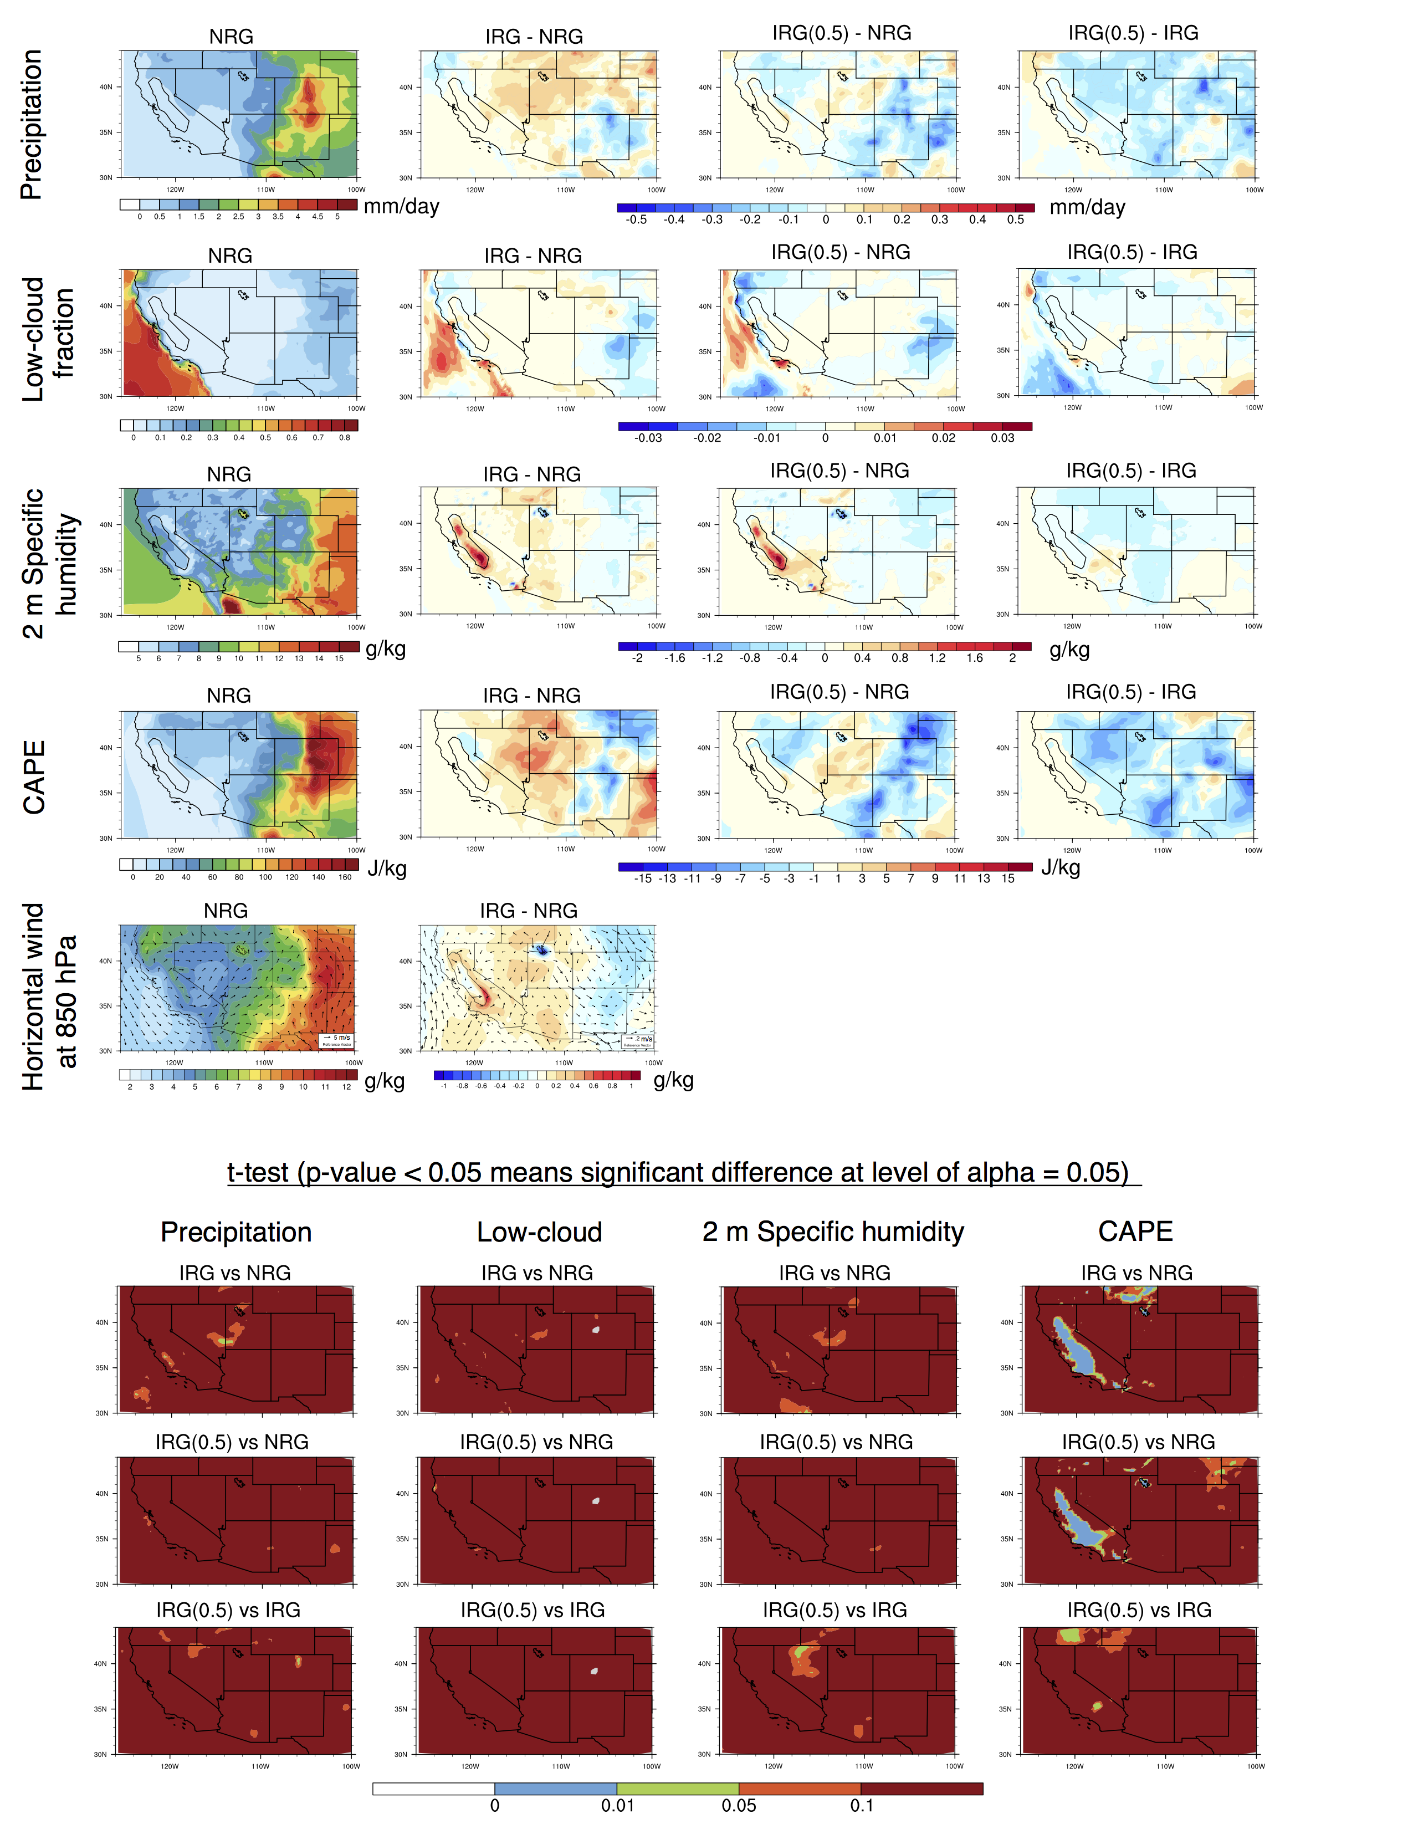

**Figure 2 Averaged JJA Precipitation, low-level cloud, near-surface specific humidity and CAPE of all the simulations and their differences with t-test results based on year 1980-2005 period.**

References:

Lo, M.-H., and J. S. Famiglietti (2013), Irrigation in California’s Central Valley strength- ens the southwestern US water cycle, Geophysical Research Letters, 40 (2), 301–306.

Sorooshian, S., Li, J., Hsu, K. L., & Gao, X. (2011). How significant is the impact of irrigation on the local hydroclimate in California’s Central Valley? Comparison of model results with ground and remote‐sensing data. *Journal of Geophysical Research: Atmospheres*, *116*(D6).

4. Significant test for the differences in Figure 3 might be worth.

**Yes. For figure 3, area with significant differences between NRG and IRG are already denoted with hatching. For figure 4, we did both t-test for mean differences and F-test for interannual-variation differences, and results have also been incorporated into the manuscript.**

5. The argument regarding the soil water's variations needs to be carefully revised. Line 269~276, usually the sub-layer soil moisture has slow (or smaller) variability so that even with 4% of changes, the variations are still significant. Although it's 4 %, the amount of the water might be quite significant when we consider the 1st thin soil layer in CLM. Thus, the authors may want to provide more evidences to support their argument on Line 275~276: "This suggests that irrigated water does not effectively infiltrate into lower soil layers."

**Agreed. We have emphasized this point in the revised manuscript. We realized that we have averaged the soil moisture based on all the ground levels specified in CLM4.0, which include not only ten soil layers but also five hydrologically inactive layers (i.e. soil water is all zero) at the bottom. We have corrected the column-averaged soil moisture to be averaged only over the ten soil layers, with corresponding changes made in the manuscript. This only changed the absolute values of soil moisture variable. The relative differences between all simulations is unaffected.**

**Thank you for pointing out the different tendencies that may appear within the groundwater among the subsurface layers. It is true that the soil moisture at lower levels has smaller variability compared to upper levels in our study area, and increases in the amount of soil water are significant among all layers under irrigation. Although the averaged soil moisture over all layers only changed 4.4%, the relative enlargement of soil water is more than 10% for the topmost five layers (reaching ~52% at the ground surface as aforementioned). Therefore, the amount of the water is indeed quite significant when we consider only the first few thin soil layers in CLM.**

**As for infiltration efficiency, we note that the small difference (1.4%, still significant at level 0.05) of soil moistures between IRG and IRG (0.5) might suggest that irrigated water does not effectively infiltrate into lower soil layers, given the irrigated water amount of IRG is more than two times of IRG (0.5). We investigated further and found that the soil water between IRG and IRG (0.5) is significantly different at the ground surface (~5% changes) and the bottom layers (~1% changes), but not for near-surface and middle levels.**

**On lines 278-283 of the revised manuscript, we have replaced the sentence** “Nonetheless, the soil moisture averaged over all the subsurface layers only showed a slight increase (~4%) under irrigation, although this value is still statistically significant under the t-test.” **with “The soil moisture averaged over all surface and subsurface soil layers showed a statistically significant increase (4.4%) under irrigation. Since variability of the soil moisture is smaller at lower levels compared to upper levels, even a 4.4% change in the total column average was significant. The change in soil moisture was largest near the surface, with soil water in the topmost five soil layers increased by 10% (reaching ~52% at the first thin layer).”**

**On lines 284-295, we replaced the sentences** “Although the irrigated water added in IRG(0.5) was nearly half of that in IRG, it did not lead to statistically significant differences for those relevant variables, and simply led to smaller runoff (parameterized by removing surface water after infiltration into the soil) (~0.24 mm/day) compared with IRG (~1.6 mm/day). This suggests that irrigated water does not effectively infiltrate into lower soil layers.” **with the paragraph “Notably, the small difference in column soil moisture (averaged over all the ten soil layers) between IRG and IRG(0.5) (equal to about 1.4%, but still significant at the 95% level) suggests that irrigated water does not effectively infiltrate into lower soil layers, given that the irrigated water applied in IRG is more than two times that of IRG(0.5). The soil water between IRG and IRG(0.5) is significantly different at the ground surface (~5% difference) and in the bottom layers (~1% difference), but not at the near-surface and throughout the middle levels. In fact, most of the additional water (~1.57 mm/day) from IRG(0.5) to IRG directly led to surface runoff (parameterized by removing surface water after infiltration into the soil at ~0.24 mm/day for IRG(0.5) and ~1.6 mm/day for IRG). Since irrigation water use in the IRG simulations is comparable to observations, this suggests that ineffective infiltration could be driving substantial water waste in the CV.”**

**In Table 2 and Figure 4, we have updated the soil moisture values.**

References:

Oleson, K., D. Lawrence, G. Bonan, M. Flanner, E. Kluzek, P. Lawrence, S. Levis, S. Swenson, P. Thornton, A. Dai, M. Decker, R. Dickinson, J. Feddema, C. Heald, F. Hoffman, J. Lamarque, N. Mahowald, G. Niu, T. Qian, J. Randerson, S. Running, K. Sakaguchi, A. Slater, R. Stockli, A. Wang, Z. Yang, X. Zeng, and X. Zeng (2010), Technical Description of version 4.0 of the Community Land Model (CLM), NCAR Tech- nical Note NCAR/TN-478+STR, National Center for Atmospheric Research, Boulder, Colorado, doi:10.5065/D6FB50WZ.

Beven, K. J., & Kirkby, M. J. (1979). A physically based, variable contributing area model of basin hydrology/Un modèle à base physique de zone d'appel variable de l'hydrologie du bassin versant. *Hydrological Sciences Journal*,*24*(1), 43-69.

Niu, G. Y., Yang, Z. L., Dickinson, R. E., & Gulden, L. E. (2005). A simple TOPMODEL‐based runoff parameterization (SIMTOP) for use in global climate models. *Journal of Geophysical Research: Atmospheres*, *110*(D21).

Entekhabi, D., & Eagleson, P. S. (1989). Land surface hydrology parameterization for atmospheric general circulation models including subgrid scale spatial variability. *Journal of climate*, *2*(8), 816-831.

6. In figure 3, WHY does the IRG(0.5) experiment always have a larger variability compared to that in IRG experiment? Also, do the soil moisture include all the layers?

**We assume the reviewer refers to Figure 4. This is a good observation. We performed an F-test to assess if the interannual-variability differs at the significance level of 95%. It was observed that the larger variability of IRG(0.5) compared against IRG was significant for soil moisture, but not for Tmax, precipitation and latent heat flux.**

**Being in between IRG and NRG, we suppose that the limited cooling effect from IRG(0.5) tends to result in a slightly higher Tmax and larger variability compared to IRG. Higher Tmax is also related with higher variability in latent heat flux, and relatively lower soil moisture tending to be more variable when comparing all the three runs. Considering the large variability of precipitation itself, the difference of the variability between the irrigation runs is still within the inter-annual variability of precipitation.**

**Yes, the soil moisture includes all the layers. As mentioned in Q5, we have corrected the soil moisture values to include all the soil layers.**

7. The spin-up is one year in this study. The authors need to check (1) How's the groundwater aquifer's evolution? Does it reach to the equilibrium? (2) the deeper soil moisture's evolution and whether it reaches the equilibrium. How it might affect the results in this study?

**Thanks for pointing out this. In fact, initial soil moisture conditions were specified from the output of long-term simulations so as to ensure the soil moisture/groundwater aquifer was in equilibrium with the local climatology. Therefore, we anticipate long-term spin-up is not necessary in this case and that our results will not be affected by a prolonged spin-up period.**

**To demonstrate this was the case, we ploted the averaged JJA soil moisture over the CV at each layer and within each year in the following figure. We can see that soil moisture conditions over the first couple years of the study are comparable to the latter years.**

**On lines 161-163 of the revised manuscript, we have added “Initial soil moisture conditions are specified from the output of long term simulations so as to ensure the groundwater aquifer was initially in near-equilibrium with the local climatology.”**



**Figure 3 Averaged JJA soil moisture at each layer from year 1980 to 2005 in CV.**

8. I guess the Figures 4 and 5 are the averaged from 25 years? If that is the case, can the authors add the uncertainty (interannual variations) on the figure?

**Yes, Figure 4 does use the annual average from 25 years. But, Figures 5 is based on all daily Tmax values, rather than the averaged Tmax from 25 years. As for interannual variation for Figure 4, we have included this information in the text as the interquartile range already provides some information on variability.**

9. Line 359~360: "Since CLM does not simulate subsurface flow, which would be taken care of by an independent watershed model, it lacks realistic control of water infiltration or ground water replenishment."

Please check the CLM's technical report on the CLM's parameterization regarding the groundwater flow.

**Thanks for pointing this out. We have corrected and clarified this statement. The surface and subsurface runoff are taken care of by CLM 4.0. According to the technical report of CLM 4.0 [Oleson et al. 2010], the river route model (RTM) was developed to route total runoff from the land surface model to either the active ocean or marginal seas, and is needed to model ocean convection and circulation. In our simulations, RTM is not enabled, since it lacks realistic control of water infiltration or groundwater replenishment. For us, the runoff simply exits to a nearby river and then ends up in ocean. However, future work aims to incorporate the use of an integrated hydrological modeling system (e.g. PFLOTRAN, ParFlow or IWFM). We hypothesize that an integrated system is necessary to correctly represent the regional hydrological processes impacted by irrigation.**

**In the lines 412-421, the sentence** “Since CLM does not simulate subsurface flow, which would be taken care of by an independent watershed model, it lacks realistic control of water infiltration or ground water replenishment.” **has been changed to “… and the runoff is parameterized by the simple TOPMODEL-based [Beven and Kirkby, 1979] runoff model (SIMTOP) described by Niu et al. [2005]. In CLM 4.0, the surface and subsurface runoff are assumed to be washed into nearby rivers and then end up in ocean. CLM 4.0 does provide a simple river routing model (RTM), which was not enabled in our simulations since it lacks the realistic control of water infiltration or groundwater replenishment present in a watershed model. To accurately address the implications of irrigation, we expect that a coupled integrated hydrological modeling system is necessary to correctly represent regional hydrological processes.”**

Reference:

Oleson, K., D. Lawrence, G. Bonan, M. Flanner, E. Kluzek, P. Lawrence, S. Levis, S. Swenson, P. Thornton, A. Dai, M. Decker, R. Dickinson, J. Feddema, C. Heald, F. Hoffman, J. Lamarque, N. Mahowald, G. Niu, T. Qian, J. Randerson, S. Running, K. Sakaguchi, A. Slater, R. Stockli, A. Wang, Z. Yang, X. Zeng, and X. Zeng (2010), Technical Description of version 4.0 of the Community Land Model (CLM), NCAR Tech- nical Note NCAR/TN-478+STR, National Center for Atmospheric Research, Boulder, Colorado, doi:10.5065/D6FB50WZ.

Reviewer #2 Evaluations:

General comments.

This paper outlines a model experiment to test the effectiveness of a variable resolution RCM in reproducing atmospheric effects of intensive irrigation in the Central Valley CA. While not earthshattering (studies have shown these effects in other intensive irrigation regions), the results do demonstrate that the model reasonably reproduces temperature effects. However the model appears to be biased high with respect to precipitation (fig 4C) and so I don't believe the authors can make any reasonable claims about precipitation impacts. This paper is well written and is worthy of publication once the following questions have been addressed.

Specific comments.

Lines 167-168: Given the importance of CV irrigation, it seems that there should be an estimate of CV irrigation area so that authors don't have to assume half.

**We did try to determine if there are accurate numbers for the irrigation area and irrigation water over the Central Valley. Research on the subject included scouring technical reports, policy briefs and the scientific literature, and reaching out to our peers in the academic community that work on agriculture in the CV. What we learned is that it is hard to estimate these values precisely since there has been no requirement for public disclosure of water withdrawals from private wells. Further, irrigation amounts vary by year since land use (in particular fallowing) varies annually, and depends on the winter rainfall and summer surface water supply.**

**In addition, variations in irrigation practices can substantially impact these numbers, along with the knowledge that irrigation methods often change depending on choice of crop. Unfortunately, there is no reliable and comprehensive dataset on land use and information is even sparser on irrigation methods employed by growers.**

**For our study, as we stated in the paper, the USGS reported that in the year 2000, approximately 42 km^3 of water was used over ~41,000 km^2 of irrigated area within California. Combining with the land-use data, used for computing cropland (independent of specific type) that is equipped for irrigation within each grid cell for the year 2000 [Siebert et al. 2005], we arrived at the estimation of the irrigation area of CV of about 33,190 km^2, which is about 81% of the total irrigation area. Therefore, in our paper, we assume that between half to two thirds of the 42 km^3 of water was employed over the CV during JJA (excluding certain water amount for late spring and early fall), that resolves to about 21 to 28 km^3, or 0.66 to 0.88 times the amount used by IRG (~32 km^3).**

**On lines 169-173 of the revised manuscript, we added “Given that no reliable and comprehensive dataset on cropland utilization or fallowing is available, and that information on local irrigation practices is even harder to come by, it was determined that there was no precise and publicly available numbers for the irrigation area and total utilized irrigation water over the CV.”**

**One lines 175-177, we added “Based on the fraction of cropland equipped for irrigation in the year 2000 obtained from Siebert et al. [2005], we arrived at an estimate of CV irrigated area of about 33,190 km2, which is about 81% of California's total irrigated area.”**

Reference:

Siebert, S., P. Do ̈ll, J. Hoogeveen, J.-M. Faures, K. Frenken, and S. Feick (2005), Development and validation of the global map of irrigation areas, Hydrology and Earth System Sciences Discussions Discussions, 2(4), 1299–1327.

Lines 231-232: How much of a difference in irrigation demand does 0.5 make relative to 0.7?

**We are not exactly sure what the term “irrigation demand” refers to here. If it means the w_{target} - w_{current} in the irrigation scheme equation (1), this is exactly the amount of added water, which changes from ~1.27 mm/day to ~2.84 mm/day with irrigation factor from 0.5 to 0.7.**

Lines 265-266: This seems to suggest a lot of wasted irrigation water.

**Agreed. Certainly we anticipate there will be substantial differences in our results that arise from the type of irrigation applied (e.g. field flooding versus drip irrigation), since the irrigation scheduling can be practiced in a number of ways to determine when and how much water to apply [Canessa et al. 2011].**

Reference:

Canessa, P., Green, S., & Zoldoske, D. (2011). Agricultural water use in California: a 2011 update. *Center for Irrigation Technology, Fresno State University, November. http://www.californiawater.org/cwi/docs/CIT_AWU_REPORT_v2. pdf*.

Lines 269-270: again, irrigation water is not going to soil moisture but to evaporation, begging better irrigation water management.

**Agreed. Please see above.**

Lines 286-287: there are many studies to support increased convection due to irrigation.

**Yes. There are many studies to support increased convection due to irrigation by modifying the depths of planetary boundary layer, lifting condensation level, and mixing layer [Kawase et al. 2008; DeAngelis et al. 2010; Qian et al. 2013]. We also observe a statistically significant increase in CAPE over irrigated region and a little part of its surrounding area in our results (see Figure 2).**

**In line 311-316, we have added “This is possibly due to enhanced local convective processes driven by irrigation modifying the depth of planetary boundary layer, lifting condensation level, and mixing layer (also found by Kawase et al. [2008]; DeAngelis et al. [2010]; Qian et al. [2013]). A statistically significant increase in convective available potential energy (CAPE) over the irrigated region and part of its surrounding area was observed in our results (see Figure 3 in the supplement).”**

References:

Kawase, H., Yoshikane, T., Hara, M., Kimura, F., Sato, T., & Ohsawa, S. (2008). Impact of extensive irrigation on the formation of cumulus clouds.*Geophysical Research Letters*, *35*(1).

DeAngelis, A., Dominguez, F., Fan, Y., Robock, A., Kustu, M. D., & Robinson, D. (2010). Evidence of enhanced precipitation due to irrigation over the Great Plains of the United States. *Journal of Geophysical Research: Atmospheres*,*115*(D15).

Qian, Y., Huang, M., Yang, B., & Berg, L. K. (2013). A modeling study of irrigation effects on surface fluxes and land–air–cloud interactions in the Southern Great Plains. *Journal of Hydrometeorology*, *14*(3), 700-721.

Lines 345-347: Can authors explain the difference in study results?

**Yes. Since this topic is also brought up from the first reviewer’s comments in Q3, please refer to this earlier response for our explanation.**

Lines 356-358: if CV is so flat, how can the model generate runoff rather than infiltration? Are the soil properties reasonable?

**We acknowledge that there is a deficiency in the treatment of the water budget in this study. In particular, CLM 4.0 does not account for the eventual fate of “runoff”, even though it is likely that in flat regions, such as the CV, this water can play a much more active role in the water cycle prior to being deposited in the ocean. We are very interested in eventually duplicating this study with an integrated hydrological model so that proper accounting of the CV water budget can occur.**

**According to the technical notes for CLM4.0 [Oleson et al. 2010], the mechanism implemented in CLM 4.0 for modeling surface runoff and infiltration is roughly described here: Based on the total flow of liquid water reaching the soil surface, the simple TOPMODEL-based (Beven and Kirkby 1979) runoff model (SIMTOP) described by Niu et al. (2005) is implemented to parameterize runoff. SIMTOP simplifies the TOPMODEL runoff formulations to improve the parameterization of the fractional saturated area, especially in mountainous regions and facilitates applying TOPMODEL-based runoff schemes on global scale. The maximum infiltration capacity is determined from soil texture and soil moisture (Entekhabi and Eagleson 1989). Soil water is predicted from a multi-layer model with vertical soil moisture transport governed by infiltration, surface and subsurface runoff, gradient diffusion, gravity, canopy transpiration through root extraction, and interactions with groundwater.**

**As for the soil properties, for CLM 4.0, soil colors are from Lawrence and Chase (2007). A mineral soil texture dataset (Bonan et al. 2002b) and an organic matter density dataset (Lawrence and Slater 2008) varied with depth are created from the International Geosphere-Biosphere Programme (IGBP) soil dataset (Global Soil Data Task 2000) of 4931 soil mapping units and their sand and clay content for each soil layer. That information has been incorporated to the land cover dataset prescribed in the simulations. Comparing with the soil database (SSURGO), it seems that the soil properties used in CLM 4.0 are general reasonable.**

**On lines 412-417, we have added “According to the CLM 4.0 technical report [Oleson et al., 2010], the maximum infiltration capacity is determined from soil texture and soil moisture [Entekhabi and Eagleson, 1989] and the runoff is parameterized by the simple TOPMODEL-based [Beven and Kirkby, 1979] runoff model (SIMTOP) described by Niu et al. [2005]. In CLM 4.0, the surface and subsurface runoff are assumed to be washed into nearby rivers and then end up in ocean.”**

References:

Oleson, K., D. Lawrence, G. Bonan, M. Flanner, E. Kluzek, P. Lawrence, S. Levis, S. Swenson, P. Thornton, A. Dai, M. Decker, R. Dickinson, J. Feddema, C. Heald, F. Hoffman, J. Lamarque, N. Mahowald, G. Niu, T. Qian, J. Randerson, S. Running, K. Sakaguchi, A. Slater, R. Stockli, A. Wang, Z. Yang, X. Zeng, and X. Zeng (2010), Technical Description of version 4.0 of the Community Land Model (CLM), NCAR Tech- nical Note NCAR/TN-478+STR, National Center for Atmospheric Research, Boulder, Colorado, doi:10.5065/D6FB50WZ.

Beven, K. J., & Kirkby, M. J. (1979). A physically based, variable contributing area model of basin hydrology/Un modèle à base physique de zone d'appel variable de l'hydrologie du bassin versant. *Hydrological Sciences Journal*,*24*(1), 43-69.

Niu, G. Y., Yang, Z. L., Dickinson, R. E., & Gulden, L. E. (2005). A simple TOPMODEL‐based runoff parameterization (SIMTOP) for use in global climate models. *Journal of Geophysical Research: Atmospheres*, *110*(D21).

Entekhabi, D., & Eagleson, P. S. (1989). Land surface hydrology parameterization for atmospheric general circulation models including subgrid scale spatial variability. *Journal of climate*, *2*(8), 816-831.

Bonan, G.B., Levis, S., Kergoat, L., and Oleson, K.W. 2002b. Landscapes as patches of plant functional types: An integrating concept for climate and ecosystem models. Global Biogeochem. Cycles 16: 5.1-5.23.

Lawrence, P. J., & Chase, T. N. (2007). Representing a new MODIS consistent land surface in the Community Land Model (CLM 3.0). *Journal of Geophysical Research: Biogeosciences*, *112*(G1).

Lawrence, D.M., and Slater, A.G. 2008. Incorporating organic soil into a global climate model. Clim. Dyn. 30. DOI:10.1007/s00382-007-0278-1.

Table 2: The difference in irrigation between IRG and IRG(0.5) is ~1.6 mm/day, which is exactly how much runoff is generated in the IRG simulation. Authors should point to this as evidence of a lot of irrigation water waste, since the IRG simulates a comparable amount of irrigation demand as actually observed.

**Agreed. Nearly 88% of the extra irrigation water has ended up as surface runoff. We have emphasized this water waste in the revised manuscript.**

**On lines 290-295, we have added “In fact, most of the additional water (~1.57 mm/day) from IRG (0.5) to IRG directly led to surface runoff (parameterized by removing surface water after infiltration into the soil at ~0.24 mm/day for IRG (0.5) and ~1.6 mm/day for IRG). Since irrigation water use in the IRG simulations is comparable to observations, this suggests that ineffective infiltration could be driving substantial water waste in the CV.”**

Figure 4c seems to indicate that the model generates a lot more extreme rainfall than is observed regardless of irrigation scheme, so I'm not sure how much can really be inferred from this study regarding the effects of irrigation on precipitation.

**Precipitation is rare during the summertime in California, with the majority of precipitation arising from localized convective systems. As for observations, such as from the UW and PRISM gridded datasets, the averaged JJA precipitation over CV is ~0.13 mm/day and 0.14 mm/day respectively (~0.10 mm/day for NRG, and ~0.12 for irrigation runs). Consequently, we believe the model does not present an extremely poor representation of precipitation. Precipitation impacts can still be evaluated by comparing the model with irrigation (IRG) against the unirrigated model (NRG), since differences are still informative of the underlying processes (although one needs to be careful when interpreting the precise value of the change).**

**Since the model produces enhanced convection with irrigation present, along with increased specific humidity, we can use these results to infer indirectly that “extreme” precipitation events may be enhanced. These differences would be expected even in a model where precipitation is biased since the actual precipitation processes and feedbacks are nonetheless present. Nonetheless, any enhancements are likely very small, considering the large variability of precipitation itself and the extreme dry summer over CV.**

**One line 306-310, we replaced** “Average precipitation did not significantly change among these three runs (under the Mann-Whitney-Wilcoxon test at 95% level), however adding irrigation tended to widen the range of precipitation intensity, possibly due to enhanced local convective processes.” **with the sentence “Average precipitation also did not significantly change among these three runs (under the Mann-Whitney-Wilcoxon test at 0.05 level together with the observations of ~0.13 mm/day for UW and ~0.14 mm/day for PRISM), however adding irrigation tended to widen the range of precipitation intensity (significantly different, with inter-annual variability around 0.12 to 0.13 mm/day for irrigation runs, and about 0.08 mm/day for NRG).”**

**We would like to thank both reviewers again for taking the time and effort to provide your thoughtful and thorough commentary. We hope that these revisions have addressed your concerns and believe the quality of the manuscript has been greatly improved with your input.**

**Sincerely,**

**Xingying Huang and Paul Ullrich**